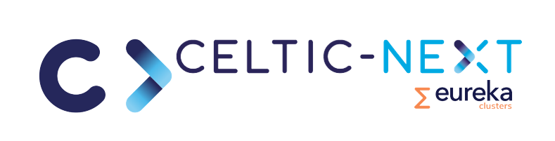

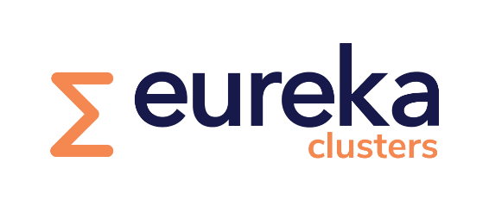

CELTIC-NEXT the EUREKA Cluster for
Next Generation Communications



Proposer’s Guide | Guidelines for Proposal Management  From Celtic Introduction to Label

© Copyright 2019 - 2026 CELTIC Office. All Rights Reserved.

The text, images and graphics included in this document may be copied, distributed and used for discussion and other non-commercial purpose, provided that when quoted, reproduced or used in any form, the source is acknowledged.

It is not allowed to produce illegal copies or make the content of this document available, completely or in part, by means of the Internet or via an Intranet, without written consent of the CELTIC-NEXT organisation, handled by the Celtic Office.

CELTIC-NEXT does not warrant that the information contained in this document is capable of use, or that use of the information is free from risk, and accepts no liability for loss or damage suffered by any person using the information.

Table of Contents
1 The CELTIC-NEXT Organisation 5
1.1 Introduction to CELTIC-NEXT 5
1.2 Structure 6
1.3 Responsibilities 7
1.3.1 Celtic Core Group 8
1.3.2 Celtic Group of Experts and Ad-hoc Committee 8
1.3.3 Celtic Office 8
1.4 Public Authorities 8

2 The CELTIC-NEXT Call Process and Project Definition 9
2.1 CELTIC-NEXT Call Phase 9
2.2 CELTIC-NEXT Work programme 10
2.3 Funding of CELTIC-NEXT projects 12
2.4 Checklist for preparing a successful proposal 13
2.5 CELTIC project Proposal Definition (CPP) 13
2.5.1 Define a project consortium 13
2.5.2 Non-Disclosure or Confidentiality Agreement (NDA) 13
2.5.3 Drafting and finalising the Proposal 14
2.6 Proposal evaluation 14
2.7 CELTIC-NEXT Label 14

3 Launching a CELTIC-NEXT project 15
3.1 Funding negotiations 15
3.2 Contracts and other legal documents 16
3.2.1 Confirmation Letter and Declaration of Acceptance (CLDoA) 16
3.2.2 CELTIC-NEXT Frame Agreement (CFA) 16
3.2.3 Project Cooperation Agreement (PCA) 16
3.2.4 Subcontracting of Project Participants 17
3.2.5 Project Change Request (PCR) 17
3.3 Kick-off a CELTIC-NEXT project 17
3.3.1 Project Description 18

4 REPORTING AND Project Deliverables 19
4.1 Basic Principles of Reporting 19
4.2 Types of project deliverables 19
4.3 Confidentiality levels of deliverables 20
4.4 Publication of project deliverables 20

5 Reviews and quality assurance 21
5.1 Project Quality Assurance 21
5.2 Deliverable Reviews 21

6 Support Services 22
6.1 Recommended Standards for Document Editing 22
6.2 EuresTools services 22

7 CELTIC-NEXT Fee - invoicing and payment Procedure 23

8 Version History 25

Annex 1: Project Reporting 26
Annex 2: Mid-term Review Forms 28

Acronyms
AR Annual Report
CFA CELTIC-NEXT Frame Agreement
CG Celtic Core Group
CLDoA Confirmation Letter-and Declaration of Acceptance
CPP CELTIC-NEXT Project Proposal
GoE Group of Experts
IPR Intellectual Property Rights
MR Monthly Report
MTR Mid-term Review
PA Public Authority
PCC Project Coordination Committee
PCO Project Coordinator
PCR Project Change Request
PD Project Description
PM Person Month
PO Proposal Outline
PRO CELTIC-NEXT Programme Coordinator
PY Person Year (= 12 PM)
QR Quarterly Report
SME Small Medium Enterprise
TC Technical Committee
TCO Technical Coordination Committee
TL Task Leader
WPL Work Package Leader
WPT Work Package Team
WS Work Summary
About this Proposer’s Guide
CELTIC-NEXT has prepared this Proposer’s Guide as a general guideline and tool to assist projects and participants in preparing proposals and for successfully running projects. This Guide is the first of the two guidelines to assist you in running a project successfully. This Proposer’s Guide is for the proposal phase before the CELTIC-NEXT label. A Project Management Guide is available for helping participants after their project has been labelled.
The Guideline should be regarded as a living document. Described processes may be improved; new practices may be added if it turns out that this would be useful for the project definition and management. Only a few methods are mandatory and must be followed by the project participants. However, most of the described processes should be regarded more as recommendations and suggestions for good practice.
The purpose of the CELTIC-NEXT Proposer’s Guide is to provide information about established processes related to the following:
- Explanation of CELTIC-NEXT call process and project definition
- Definition and submission of proposals and deliverables
- Illustration of a project launching and reporting
- Evaluation and labelling of projects
- Reporting and quality assurance of results
- CELTIC services and support

The CELTIC-NEXT Organisation

Introduction to CELTIC-NEXT
CELTIC-NEXT is a follow-on programme to the successful Celtic-Plus EUREKA ICT cluster programme and its predecessor “Celtic-Initiative”. Overall, CELTIC has contributed significantly to the growth of the annual turnover of firms involved in cluster projects (+13 % compared to non-participating firms) and to the development of employment (+7% employment growth compared to non-participating firms). CELTIC-NEXT has been defined for 8 years until the end of 2026. CELTIC is supported by nearly all major European players in telecommunications.
CELTIC-NEXT is an industry-driven European research initiative to define, perform and finance through public and private funding common research projects. Bringing the major European telecommunications vendors and operators together into an ambitious European intergovernmental R&D programme that tackles the main means related to an end-to-end approach in communications. CELTIC is the best option to address a “system view” of communications to complement other existing Clusters.
CELTIC has been key for initiating ambitious and innovative projects dedicated to end-to-end communications solutions.
Until today, CELTIC has labelled, funded and performed 150 projects in all their research areas with a total volume of more than one Billion Euro. By facilitating these collaborative R&D projects, CELTIC has made a great contribution to help Europe to stay at the competitive edge of the telecommunications industry.
The participation of SMEs in CELTIC has continuously increased throughout the years, to reach more than 40%. In 2018, the total budget of SMEs in CELTIC projects overcomes the total budget of large Industry
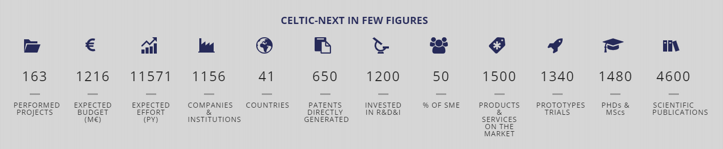
CELTIC-NEXT is a EUREKA ICT cluster and belongs to the inter-governmental EUREKA network.
There are critical technological and societal issues that need to be addressed in the coming years, that are not addressed by other EUREKA instruments, and only partially by other instruments in Europe. From a technological standpoint, Networking and Cloud Enablers addressing and using technology from such research areas as cyber security, artificial intelligence, 5G and beyond, Fin-Tech, big data, business analytics, and IoT are considered as important orientations to develop. A special focus of CELTIC-NEXT will be on applications and services serving vertical sectors such as content (video, gaming), e-health, smart cities, agriculture, mobility, energy, automotive, e-commerce, and industry/ manufacturing. Those verticals are equally important to advance, along with optimising and improving efficiency and reliability with the best end-to-end connectivity and security. The evolution of ICT services over the next period will be achieved via a partnership model where the vertical sectors collaborate in determining their ICT solutions. This will be a key focus of the CELTIC-NEXT end-to-end perspective.
Another key issue for CELTIC-NEXT will be to develop communications infrastructures and services that can adapt to the requirements of various business sectors. The need for communications between vehicles is quite different from the need to pilot electrical power in buildings and houses. The same applies to the virtual and immersive reality techniques that will become a critical element in the health and media/digital industry in the coming years. There will be many unique challenges behind innovative manufacturing processes that must be supported by one ubiquitous infrastructure. We expect that many of the CELTIC-NEXT projects will define and develop self-adaptable solutions to fit the needs of many different sectors and societal challenges. CELTIC-NEXT with its end-to-end approach is key for allowing the development of dedicated applications using the network with all the required features for a given economic sector.
Representatives from vertical sectors are progressively invited to participate in the CELTIC-NEXT Industry Core Group to ensure the continuous cross-fertilisation of ideas. In parallel, the telecommunications industry shall exploit the full power of cross sectors technologies such as Artificial Intelligence and Big Data, to define and provide customised and smart solutions for the different economic sectors and the whole society.
The scope and purpose of the CELTIC-NEXT Organisation are to stimulate, organise and coordinate research and development work within the goals of the CELTIC-NEXT Programme executed by CELTIC-NEXT Participants. CELTIC-NEXT is a not-for-profit organisation.
The primary CELTIC-NEXT objectives are to:
- Carry out pre-competitive R&D focusing on Integrated System Solutions with regard to a system view, basic technologies and sub-systems
- Enabling trials and evaluations of Service concepts, Technologies, System solutions and business models
- Be open to pre-competitive cooperation, including other R&D initiatives.
As CELTIC-NEXT is a EUREKA cluster programme a number of administrative requirements need to be observed and followed to assure that CELTIC-NEXT projects are set up, managed and controlled according to established and required rules.

Structure
The CELTIC-NEXT Organisation is composed of the following management bodies:
- CELTIC Core Group: The CELTIC Core Group consists of currently 19 members from 10 countries. Members of the Core Group are mainly from the European telecoms industry. The Core Group is responsible for the general policy of CELTIC-NEXT and its research activities. Core Group members drive many project proposals.
- Management team: The CELTIC-NEXT Management Team consists of the Core Group chair and the Celtic Office Director. The Team is responsible for general CELTIC-NEXT management issues.
- CELTIC Office: The Celtic Office is responsible for the day-to-day management of the CELTIC-NEXT programme. It organises the calls for project proposals, the project evaluation, the labelling and the project reviews. It also provides the support needed to projects, proposers and interested communities and organises regular CELTIC-NEXT events and Proposers Days.
- CELTIC Group of Experts: The Group of Experts (GoE) is responsible for the evaluation of project proposals and for taking part in Celtic project reviews. The GoE will comprise several sub-groups accountable for a particular technical area. Core group members will nominate members of the GoE, and an expert will chair each GoE.
- CELTIC-NEXT Ad-hoc Committees: The CELTIC Core Group may install from time to time and for a limited duration a CELTIC Ad-Hoc Committee, which has delegated responsibilities and which shall execute specific tasks and responsibilities. As an example, CELTIC Ad-Hoc Committees may be created to assist the Core Group or the Group of Experts with monitoring the progress of the projects.
- CELTAC (CELTIC-NEXT Authority Committee): For CELTIC-NEXT, the National Public Authorities are organised in the ‘Celtic Public Authorities Committee’ (CELTAC). Public Authorities are involved in CELTAC through common meetings with the CELTIC Core Group in the selection process of received proposals.
The figure below demonstrates the inter-relationships of the different bodies:
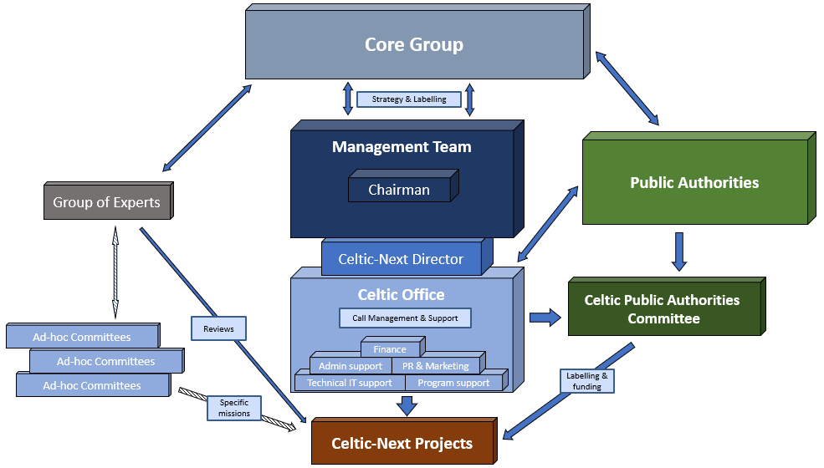
Figure 1 CELTIC-NEXT Organisation Structure

Responsibilities
    - Celtic Core Group
The Core Group is the main executive body. It is formed by the founding members (Adtran Networks SE, British Telecom, Deutsche Telekom, Ericsson, Eurescom GmbH, imec, Indra Group, Nokia, Orange-Labs, SES S.A., Telefónica I+D, Telenor, Thales, Turkcell, Türk Telekom) and is led by a chair and CELTIC-NEXT director.
 |  |  |  | 
 |  |  |  | 
 |  |  | 
 |  |  | 

The CELTIC-NEXT Core Group is mainly responsible for the:
- Programme strategy and coherence;
- Representation of the Programme in front of Public Authorities;
- Interface and influence to the PAs for all issues related to the CELTIC-NEXT Programme;
- Decision on tasks and guidelines for the CELTIC-NEXT Support Group (e.g. for Project selection and CELTIC-NEXT participant search);
- Definition and updating of guidelines for the structure and organisation of the Programme; the admission and control of rules for Programme and Project management;
- Selection of Projects, assisted by the CELTIC-NEXT Support Group’s recommendations;
- Execution and overall management of the Programme;
- Decision on Projects in individual cases;
- Approval of the budget for the CELTIC-NEXT Organisation
- Financial audit of the CELTIC-NEXT Organisation
The CELTIC-NEXT Industry Core Group ensure the continuous cross-fertilisation of ideas. In parallel, the telecommunications industry shall exploit the full power of cross sectors technologies, such as Artificial Intelligence and Big Data, to define and provide customised and smart solutions for the different economic sectors and the whole society.
    - Celtic Group of Experts and Ad-hoc Committee
The Celtic Core Group may install from time to time and for a limited duration a Celtic-Ad Hoc Committee, which has delegated responsibilities and which shall execute specific tasks and responsibilities. As an example, Celtic Ad Hoc Committees may be created for the purpose of assisting the Celtic Core Group or the Celtic-Group of Experts with monitoring the progress for the PAs.
The Group of Experts (GoE) is responsible for the evaluation of project proposals and for taking part in Celtic project reviews. The GoE will be composed by several sub-groups, responsible for a particular technical area. Each GoE will be chaired by an expert. Members for the GoE will be nominated by Core group members.
    - Celtic Office
The Celtic Office, which is hosted at Eurescom in Heidelberg, Germany, is a facilitator for project consortia building and it will ensure the day-to-day administration and follow-up of the Programme. The Celtic Office is formed by a team of experts, headed by the Director.
The Celtic Office will have the following tasks and responsibilities:
- General administration of the Programme,
- Accounting and billing of participation fees,
- Payment of Celtic Office costs, Celtic Office personnel according to the budget plan,
- Admission and control of the rules for participation to the Programme,
- Interface for all CELTIC-NEXT Participant, organisation of a Programme database,
- Monitoring of Projects, assisted by the CELTIC-NEXT Support Group, under Celtic Core Group responsibility,
- Organisation of reporting and reviewing activities at Project and Programme levels (Technical Reports, handling of Change Requests, Project Reviews, Programme Review, Forums,…),
- Information and communication to the CELTIC-NEXT Participants,
- Communication to the outside and interface with the PAs on general funding issues, following instructions of the Celtic Core Group,
- Support and assistance to all other executive bodies in the CELTIC-NEXT Organisation.

Public Authorities
The Public Authorities are the national contact points for the application of national project funding. For Celtic the Public Authorities are organised in the ‘Celtic Public Authorities Committee’ (CELTAC). Each EUREKA country has, at least, one representative who acts as the official Public Authority. In many cases a dedicated responsible has been nominated for the CELTIC-NEXT cluster.
Public Authorities are involved in CELTAC through common meetings with the Celtic Core Group in the selection process of received proposals.
The availability of national funding, the conditions to receive funding, and the rules on the application for national funding are very different from country to country. Contact details of Public Authorities and specific funding and application conditions are available from the CELTIC-NEXT web site.

The CELTIC-NEXT Call Process and Project Definition

  - CELTIC-NEXT Call Phase
CELTIC-NEXT has two calls per year one in Spring and one in Autumn Call. CELTIC-NEXT label decisions will be made on fully defined CELTIC-NEXT Proposals (CPP). For projects with participation from SWEDEN an Extended Abstract can be submitted until 1 month before the Call deadline. To speed up the process the Swedish funding agency VINNOVA proposes an early feedback channel to speed up funding decision after labelling. For this please fill in the Extended Abstract Form and submit it to the CELTIC Office. You will receive feed-back before the Call deadline.
The call process is shown in the figure below:
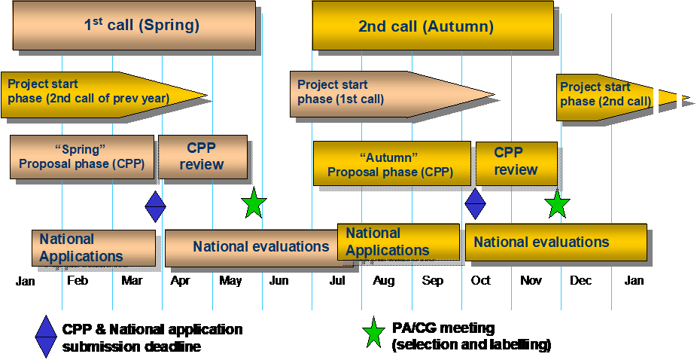
Figure 2 Yearly Call Scheme

The Spring Call generally starts at the beginning of a year and ends around end March. The Autumn Call starts in June and ends around early to mid October.
Each call lasts only around 6 months until a label may be assigned for the succeeding proposals. In order to speed up the set-up process for the labelled calls the following changes must be observed:
- Already at an early project definition phase, contacts with the involved Public Authorities must be established.
- At the same time when submitting the proposal to Celtic funding applications have to be sent to each involved Public Authority. In case an official application cannot be submitted (e.g. because no national call is currently running) a pro-forma or provisional application (e.g. for eligibility check), in accordance with the concerned Public Authority should be submitted instead.
- While the Celtic Group of Experts will evaluate the submitted proposals the Public Authorities will also evaluate the proposals and also the funding applications.
- At the common meeting Celtic Core Group and Public Authorities will agree on all suitable proposals to receive the Celtic label.
- The further set-up process can then start and the funding decisions will be further handled by the Public Authorities.
It is important to know that there will no longer be a “conditional label” assignment. A proposal may either be accepted and receive the label or it will be rejected. However, for certain proposals a re-submission of an improved proposal may be possible at the next call (i.e. 6 months later). It may, however, also be possible that a labelled proposal may receive some important improvement requests, which have to be considered before the project can start.
In the following chapters recommendations are given for the definition of good proposals as well as further details of the call process and proposal evaluation.
  - CELTIC-NEXT Work programme
CELTIC-NEXT Scope and Research Areas
The possible research areas of CELTIC-NEXT projects are described in the CELTIC-NEXT Scope and Research Areas document.
CELTIC-NEXT projects are oriented along the societal trends and needs, commercial opportunities, and technological challenges in our global society. CELTIC-NEXT with its end-to-end approach is key for allowing the development of dedicated applications using the network with all the required features for a given economic sector. To respond to societal challenges, solutions are required at multidisciplinary level. CELTIC-NEXT intends to liaise with related initiatives in order to address global solutions. Other EUREKA clusters in energy, water technologies, manufacturing industry, but also the other clusters, are the first candidates.
There are critical technological and societal issues that need to be addressed in the coming years, that are not addressed by other EUREKA instruments, and only partially by other instruments in Europe. From a technological standpoint, Networking and Cloud Enablers addressing and using technology from such research areas as cyber security, artificial intelligence, 5G and beyond, FinTech, big data, business analytics, and IoT are considered as important orientations to develop. A special focus of CELTIC-NEXT will be on applications and services serving vertical sectors such as content (video, gaming), e-health, smart cities, agriculture, mobility, energy, automotive, ecommerce, and industry/ manufacturing. Those verticals are equally important to advance, along with optimising and improving efficiency and reliability with the best end-to-end connectivity and security. The evolution of ICT services over the next period will be achieved via a partnership model where the vertical sectors collaborate in determining their ICT solutions. This will be a key focus of the CELTIC-NEXT end-to-end perspective. Another key issue for CELTIC-NEXT will be to develop communications infrastructures and services that can adapt to the requirements of various business sectors. The need of communications between vehicles are indeed quite different than the needs for piloting electrical power in buildings and houses. The same applies to the virtual and immersive reality techniques, that will become a critical element in the health and media/digital industry in the coming years. There will be many unique challenges behind innovative manufacturing processes that must be supported by one ubiquitous infrastructure. We expect that many of the CELTIC-NEXT projects will define and develop self-adaptable solutions, able to fit the needs of many different sectors and societal challenges.
CELTIC-NEXT with its end-to-end approach is key for allowing the development of dedicated applications using the network with all the required features for a given economic sector. Representatives from vertical sectors will be progressively invited to participate in the CELTIC-NEXT Industry Core Group to ensure the continuous cross-fertilisation of ideas. In parallel, the telecommunications industry shall exploit the full power of cross sectors technologies such as Artificial Intelligence and Big Data, to define and provide customised and smart solutions for the different economic sectors and the whole society.
Today, everyone listens to music and watches online videos on their mobile devices anywhere and anytime, and both businesses and individuals have their data stored in large data centres located all around the world. This creates new technological and societal challenges, primarily related to the security and privacy of data transmission and storage.
The vision of the future communications is the ongoing digitalisation and automation of many aspects of our lives — the automation of everything. This shift is driven by the current enabling technology trends like cloud-based services with dynamic and adaptive scaling, extensive virtualisation, novel software-defined automated solutions and wireless connectivity with the 5G mobile networks. We will move from an era defined by the connection of people and simple things by Mbps of capacity and ~100 ms latency to one defined by Gbps of capacity and ~1 ms of latency. This is characterised by 360-degree video, virtual and augmented reality, as well as autonomous system control with associated cognitive systems that augment human intelligence. All this will demand a fundamentally different, distributed network architecture comprised of cloud processing resources, interconnected by optimised IP and optical edge networks, and this with a converged ultrahigh capacity broadband access layer. The edge cloud network will need to support data rates of 10 Gbps, latency as low as 1 ms, and a trillion connected devices with 10+ years of battery life. Network slicing is a key capability underlying the new business model opportunities by which dedicated virtual networks to various customer groups will be provided much more economically than in the traditional model where these customers would build their own dedicated private networks. All these new capabilities will enable the communications networks to become a tool for the digitalisation of various industry areas.
Cybersecurity is a fundamental element for the Digital Transformation of the Digital Single Market aiming at both protecting the European citizens, enterprises, infrastructures or institutions against cyber-risks as well as developing the cybersecurity sector competitiveness. It applies in very diverse environment such as Cyber Physical Systems, 5G & Beyond (thus cloud), social networks, web-based applications. Mastering the creation of value from Big Data will be a cornerstone in the future economic development and societal well-being. To achieve that goal CELTIC-NEXT will work on Big Data challenges and pave the way to strengthen all parts of the “data value chain” so that a Big Data value ecosystem and data-powered innovative business models can evolve. That includes people and organisations involved in data whatever their role, be it producing, analysing, using or creating value from data.
Concerning Artificial Intelligence (AI), key research targets include learning with fewer examples, the application of learning methods to dynamic systems, the capability to explain AI decisions, the combination of AI with model based optimisation, the development of machine learning methods coping with distributed data sources and computing processors.
The development of AI and Big Data is one more incentive for users and consumers to take better control of one’s digital life in the forthcoming years. Concretely it means that users will need to be accompanied in their usage and in their need of transparency and control of the digital tools. The future digital platforms and tools will need to strike the right balance between empowering and assisting the users versus giving them the control and the choice. Privacy issues will need to be taken care of, not only but especially in the eHealth domain. CELTIC-NEXT will work on the research challenges in the eHealth sector, such as high reliability and guaranteed Quality of Service; high security, privacy and authentication; Scalability to high number of users, as well as ease of use for non-ICT specialists.
Besides eHealth another vertical is related to smart cities. Considering the continuous fast growth of wireless Internet usage and the emerging new smart city applications such as smart traffic control, smart lighting (including the LED technology), self-driving cars and air quality monitoring, the smart city infrastructure will take into account the disruptions from digitalisation towards the higher level of automatisation and from the related new business models. A digital ecosystem of a future smart city will improve safety, energy efficiency, air quality, effectivity of transportation, and quality of living. “Breaking up the silos” is essential to leverage smart city opportunities. CELTIC-NEXT will help defining an open and interoperable urban platform reference architecture, forming a system of system approach. To achieve that goal and open interfaces are a prerequisite, allowing new ways of interaction between different industries.
The digital infrastructure of transportation in a city should merge all physical transport assets in a single and easily accessible platform through the use of all smart city technological enablers such as big data, IoT and 5G to provide novel services to the integrated transport system such as new business models, new transportation models and social innovations. Such smart transport platforms can form a basis of multimodal travel planners, transportation networks, mobility services, transport on demand services, tracking and tracing activities.
The services provided by the digitisation and integration of transportation platforms can benefit from crowd-sourcing based real-time user and vehicle information to enable a faster, comfortable and controllable experience to users leading to a fully personalised services and offers.
It is important that the different actors of the value chain cooperate in order to invest the best connected and autonomous vehicles: car manufacturers, OEM, electronic equipment manufacturers, IT and telecom companies and mobile operators.
Linked to the CELTIC-NEXT vision of Smart Cities our vision of the Smart Home foresees users being offered a seamless and consistent experience when interacting with products and services bridging home, on the move and integration with smart city infrastructure. The future smart home should benefit from an open ecosystem allowing third party services to be integrated with the different Smart Home elements with AI-driven service improvements and cross-service possibilities.
Smart agriculture as well as the whole agro-food sector will benefit in the coming years of the deployment of massive connected objects. Traceability will be enabled by IoT platforms, empowering agro-food sector and allowing traceability of food information for consumers. The Digital platforms for e-Agriculture and smart manufacturing should finally use common enablers for optimisation purposes. In response to ecological and budgetary issues, new consumption patterns are emerging. Personalisation and Quality of experience will be key trends, not only in ICT but also in all industry sectors. New ways for production will meet those new consumption ways. Smart manufacturing often referred as 4th industrial revolution will transform the traditional business of manufacturing of goods towards service-based business in global value chains.
Digital enterprises complement the smart manufacturing processes: Digitalization will develop at each stage of the lifecycles of the products and services from development to deployment, from purchasing to services, from manufacturing to logistics covering all the vertical processes that an enterprise has, generating value all across the stakeholders (customers, suppliers, shareholders, value chain partners, third parties etc.)
In the next years we expect a convergence of learning and work in the Enterprises. Personalised digital learning environments will help reducing skills gaps and will therefore have a very important positive impact on economy and social innovation for society. Digital Education will benefit of emerging technologies like artificial intelligence, big data analysis and machine learning, virtual reality, augmented reality, speech recognition, conversational interfaces, drones, robotics, and 3D printing.
In the media, entertainment and gaming areas, media will become immersive and highly interactive to provide ambient media consumption at home but also on the move. There will be a big focus in coming years on mixed reality. Interactive technologies such as Augmented (AR) and Virtual Reality (VR) are set to transform the ways in which people communicate, interact and share information on the internet and beyond. Besides new 5G capabilities will enable Ultra High Fidelity media and live event coverage. Content production will diversify: there will be both user and machine generated content, as well as cooperative content production.
Gaming will expand into a full immersive multi-sensorial environment. Collaborative gaming will expand while game development may also become more cooperative with users directly interacting with the developers in real time. New gaming technologies will take gamification to all business lines and industry sectors.
Sustainability and energy efficiency will get a similar range, spanning from telecom networks and services to the whole industry, transports, smart buildings, smart cities and smart agriculture. Sensors will be used to measure and take counter actions when needed. New technologies should be used to prevent, measure and communicate pollution information. New applications should exploit data for climate, and anonymised health data to warn and avoid damages at a bigger scale. Artificial intelligence with machine and deep learning may also help reduce the energy consumption.
Last but not least new markets as the internet of value may open to ICT players, such as future financial and Fintech services which have great potentials for a growing shift in the revenue pools of the operators and ICT players especially concerning the digitalisation of lending payments and investment, online P2P (person to person) money transfer, e-wallet usages, changing customer relations with online/mobile transactions and customised financial solutions and digitalisation in insurance. ICT players as new comers in the financial business should bring impressive solutions and services, achieving the desired, efficient, optimised and secure fin-tech platforms established on the needs of the citizens, governments and the actors of the technology and market value chains.

  - Funding of CELTIC-NEXT projects
For a CELTIC-NEXT project, generally, the same funding conditions and funding rules apply as for a stand-alone EUREKA project. As CELTIC-NEXT is an endorsed EUREKA cluster the access to public funding is generally easier and faster as for an independent proposal as the Public Authorities support the collaborative work programme of CELTIC-NEXT and are more closely involved in providing the funding for proposals that have been CELTIC-NEXT-labelled.
Similar to projects that are EU-funded or funded on national basis only a portion of the overall costs will be covered by the public funding. This portion depends on the national funding rules of the partners involved in a particular project.
This means that still the major part of the costs must be covered by the involved partners. This approach assures that there must be a potential business and research interest for the participants and their interest to work in a project cannot only be based on the fact that this work is paid by public money.
Differently to the funding rules of a EU project (e.g. Framework 7) there are no common funds available that are shared among the successful proposals.
Due to the fact that each country decides on own criteria on possible funding it can happen that a project may not be able to start as intended. The non-funded partner may decide to remain in the project on a self-funded basis or to step out from the project and the project may then either be restructured (e.g. by including another partner) or may it be stopped if the partner cannot adequately be replaced. In case a project partner still waits for a pending funding decision the remaining consortium may decide to start the project already and to include the partner later. This is generally recommended for partners who start their work at a later stage or where the work is not indispensable at the early stage.
  - Checklist for preparing a successful proposal
The following checklist may be helpful when preparing a proposal that could have a good chance of being accepted as a CELTIC-NEXT project. Certainly, there will be no guarantee that a proposal will be successful even if all criteria have been fulfilled. The final decision depends, of course, also on other aspects, in the forefront, on the availability of funds that, sometimes, require a prioritisation among other good proposals.
Successful proposals should comply with the following criteria:
The objectives are in line with the CELTIC-NEXT objectives described in the Scope and Research Areas
The project does not focus on competitive aspects, e.g. direct development of products
The consortium is adequate with regard to the excepted results
The composition of the consortium promises sufficient impact of the results (e.g. a good mixture of large, important companies, SMEs and academia)
All needed expertise is available and well covered in the consortium
For each involved country the national impact and expectations for new business and new products is clearly described.
The project description is well prepared and was intensively discussed in the consortium. All information is given at the required level of detail to be understood by the reviewers.
At least two partners from two different countries must be in the consortium and no partner should have a too dominating share (e.g. more than 70% of the total).
The number of involved countries does, ideally, not exceed 6 (a recommended figure by the Public Authorities). The more countries are involved the more critical becomes the funding process and the agreements among the involved countries.
  - CELTIC Project Proposal Definition (CPP)
The Celtic Project Proposal should present all details of the planned project that are needed to start the project on the basis of this information. This mean, a detailed project plan must be elaborated, including a complete project management structure, detailed project calendar, specifications of deliverables and due dates and details about the project partners. Furthermore it is required to provide reliable budget figures and work assignments. Detailed information on the requirements for a Celtic Project Proposal are given in the guidelines for proposers (CPP).
The recommended steps for the project proposal are as follows:
    - Define a project consortium
For the definition of a proposal outline it is necessary that a strong and convincing consortium is already in place. To assist companies that intend to prepare a proposal in finding additional partners CELTIC-NEXT has established a platform on its website where a consortium can search for suitable experts or experts can find a suitable project consortium. Another possibility is the CELTIC-NEXT Proposers Day. At this proposers day experts can present their ideas and attract other companies to form a consortium.
For the selection of companies for the consortium also the funding considerations and special requirements for a national consortium should be checked. As a first indication information from the Public Authorities is available on the CELTIC-NEXT Web site.
    - Non-Disclosure or Confidentiality Agreement (NDA)
In order to assure that sensitive information that is discussed during the preparation phase will not be disclosed by other partners of the proposal it is recommended that each partner signs a NDA or confidentiality agreement. This NDA assures that, in case a proposal will not succeed or a partner will step out, the confidential information will not be further used in a non-authorised or even damaging way. Examples of a NDA can be found at the CELTIC-NEXT Website. Please note that the NDA is not mandatory and the template may be modified according to the needs of the consortium.
    - Drafting and finalising the Proposal
The requirements on the structure and the level of details that should be contained in a proposal description are laid out in the Guidelines for Proposers. As a general rule the proposal must have a sufficient level of details to allow a meaningful assessment of the intended activities, the organisation of the work (project structure), the planned results, the companies involved, the time frame (calendar), and the required budget.

Before submitting your proposal you should check if the following conditions are met by your proposal outline:
Are the objectives covered in the CELTIC-NEXT Scope and Research Areas?
Are the main objectives not focusing on the development of a product (i.e. is the proposal not too close to market introduction)?
Are detailed figures given on budget needed and effort planned?
Provide the proposal sufficient details to allow a reviewer to assess the proposal?
Is there a sufficiently large consortium defined to carry out the planned work (as a minimum at least two companies from two countries must be specified)?
For the submission of the proposal an online submission tool is available that has to be used. Please follow the instructions given at the Call page.
  - Proposal evaluation
For the Celtic Project Proposals an evaluation process has been defined that will be carried out by selected qualified experts. The proposal evaluation follows to some degree the Eureka Project Assessment Methodology (PAM) but is adjusted and extended for several technical criteria. Each proposal will be evaluated and rated, generally, by 3 experts of the same Group of Experts (GoE). Within each GoE a common rating and recommendation will be produced for each proposal.
After the evaluation of Celtic Project Proposals the GoE will provide recommendations to the CELTIC-NEXT Core Group who will decide, in discussion with the Public Authorities, if a proposal should become a CELTIC-NEXT project and should receive a CELTIC-NEXT label.
The proposals in both phases are assessed and rated according to the rules laid down in the evaluation criteria.
All proposers will receive information about the outcome of the assessments after the end of each phase.
  - CELTIC-NEXT Label
Supported by the recommendations from the reviewers the CELTIC-NEXT Core Group will discuss with the Public Authorities the outcome and will decide, which projects should receive a CELTIC-NEXT label.
A CELTIC-NEXT label is the indication that the project has successfully passed the assessment and is considered a recommended CELTIC-NEXT project. For this reason the project will receive a “CELTIC-NEXT Label. This label is also recognised by the Pubic Authorities and, generally, increases the chances to receive public funding. Important note: the assignment of a CELTIC-NEXT Label does not mean that public funding will automatically be granted for that project!
The CELTIC-NEXT label is assigned not only to the project but also to all involved companies. The project and the companies are entitled to mention in publications or web pages this label and to show the CELTIC-NEXT logo. This logo may, however, only be used in connection with the project to which it was assigned. It shall not be used for general purposes. The logos for CELTIC-NEXT label can be found at the CELTIC-NEXT web site.
The assignment of the CELTIC-NEXT label requires that the project has to be started within the following twelve months. Otherwise, the assignment may be withdrawn. In case a partner withdraws from the project or fails to accept the rules of CELTIC-NEXT (e.g. payment of CELTIC-NEXT fees, reporting requirements, etc.) the CELTIC-NEXT label may be withdrawn for that company. In such case the concerned PA will also be informed about this fact.

- Launching a CELTIC-NEXT project
The set-up and kick-off process for launching a CELTIC-NEXT project is shown in the following diagram.

Figure 3 Set-up and kick-off process

After the CELTIC-NEXT label has been granted the project consortium, under the leadership of the project coordinator (PCO), can start the set-up activities for the project. The PCO will be invited to the PCO-Workshop (in January) that gives additional information for the setup phase and for the project execution. At the first place of the preparation work is the assurance of the public funding for the different consortium partners. If the funding is assured for the partners the further preparation of the contract and the technical description of the project can continue and be finalised. It may be left to the decision of the consortium to start the set-up process even if one or more partners still have no confirmed funding. This, however, bears the risk that the consortium or the project work may need to be changed in case a partner wants to step out because of no funding.

  - Funding negotiations
The first step for assuring funding is done by establishing early contacts with the Public Authorities before or during the preparation of a proposal. This is also important because for some countries fixed deadlines are defined until when applications for funding must be submitted. This may, sometimes, be even before the CELTIC-NEXT proposal phase has been closed. For some countries even an additional proposal competing applies and the partners have to submit a national proposal also.
The second important step for assuring the funding are the meetings and the discussions of the Public Authorities (PA) and CELTIC-NEXT. At those meetings the PAs of other countries that are involved in the same proposal can agree on funding. Those agreements generally facilitate the later assurance of the funding.
The consortium should also be prepared for a fall-back approach in case funding is not approved or granted not to the percentage as expected. Possible solutions could be that a partner may decide to remain in the consortium even without or with reduced funding. Other solutions could be to focus already on partners from different countries that could perhaps take over the work. This is particularly recommended in case funding possibilities be expected difficult or uncertain.
  - Contracts and other legal documents
For the preparation of proposals and the preparation of the project set-up a few legal requirements are necessary.
All legal documents described below and all forms and templates that need to be signed can be found at the CELTIC-NEXT website.
    - Confirmation Letter and Declaration of Acceptance (CLD)
The new combined agreement “Confirmation Letter and Declaration of Acceptance (CLD)” has to be signed and submitted together with the submission of the Celtic Project Proposal.
With the CLD a company confirms that it accepts the CELTIC-NEXT rules and is ready to pay the CELTIC-NEXT fees as soon as the company becomes actively involved in the indicated CELTIC-NEXT project. The CLD is also necessary for all project partners. For details on the CELTIC-NEXT fee please refer also to chapter CELTIC-NEXT Fee - invoicing and payment Procedure.
In case the CLD will not be available when the assignment of the CELTIC-NEXT label takes place those companies will receive the CELTIC-NEXT label only under the condition that the CLD will be submitted within a very short delay of two weeks. Otherwise, the CELTIC-NEXT label may be withdrawn for that company. As the withdrawal of the label may have an impact for the whole project it is strongly advised that all participants take care to send the CLD before the assessments start.
As explained in the following chapter the DoA part must be signed together with the Confirmation Letter part as one agreement. Differently to previous projects the DoA needs now to be signed for each individual project. With the DoA part, the partner agrees to accept the rules of the CFA as referred to in the Project Cooperation Agreement (PCA).

    - CELTIC-NEXT Frame Agreement (CFA)
The CELTIC-NEXT Frame Agreement (CFA) is the main legal document of the CELTIC-NEXT organisation. It had been signed by all CELTIC-NEXT parties, i.e. companies that are in the CELTIC-NEXT Core Group and who decide on the common policy and work programme of CELTIC-NEXT.
The CFA contains, in addition, a number of articles that refer to the handling of Intellectual Property Rights (IPR), patents or access rights that are important for the project consortium. Since it is the general understanding of the CELTIC-NEXT organisation that those rules are handled on a common basis they are not part of the Project Cooperation Agreement. This means that project participants need to know these rules and they have to declare that they accept them for the work in a CELTIC-NEXT project. For this reason they have to sign a Declaration of Acceptance confirming that the rules of the Frame Agreement are accepted.
    - Project Cooperation Agreement (PCA)
The Project Cooperation Agreement (PCA) is the basic legal document of the project consortium. In the PCA all individual details for the consortium partners are specified. A number of rules refer, however, to the Frame Agreement, that, by signing the CLD, is also part of the legal documents of the project.
The PCA has to be discussed within the Consortium. Changes related to the legal text in this document may be aligned. However, changes to legal text in the related Frame Agreement are, generally, not possible and acceptable only in special cases. Those cases should be forwarded to the Celtic Office for clarification and decision.
The PCA has to be signed by all participants. For practical reasons the Project coordinator sends out the final and agreed version to all participants. Each participant has to sign the signatory page (chapter 15.1) as many times as partners are in the project. The signed pages are returned to the coordinator. After all pages have been signed and returned the coordinators combines the signed pages and sends the complete PCA with all (original) signatory pages to each participant.
The PCA has to be sent to the Celtic Office. The Celtic Office reserves the right to request modifications, e.g. in case the PCA is not in line with the rules of the Frame Agreement and the Celtic Core Group could not agree to these modifications.
    - Subcontracting of Project Participants
It is possible that an, already registered project participant subcontracts work for another organisation for doing active work for the contracting project participant. In case of subcontracting the following requirements must be observed and fulfilled:
- The effort performed by the subcontracted organisation must be included in the effort of the subcontracting party (the official project participant). This mean the subcontracting partner will be charged for the effort of the subcontracted organisation. This means that the effort figures of the subcontracting partners increases by the effort for the subcontracted organisation. In this case the subcontractor will not appear as official project partner.
- Alternatively, if the project partner should be listed as official project partner, the subcontract has to indicate all effort figures of work performed in the project including the subcontracted organisation. The fees will then be charged to the subcontracting party. This requires that the subcontract is made known to Celtic and the invoicing process can be handled by the subcontracting partner.
- In the exceptional case a subcontractor shall act as a project coordinator a special authorisation from Celtic Office is required. If accepted the case has to be handled as indicated under item 2. It is not possible that the subcontracted organisation, as coordinator, will not appear as consortium partner.
    - Project Change Request (PCR)
It is not unusual that a project may need to modify their originally project planning during its lifetime. Changes in the project may happen due to a delayed start (e.g. in case some partner had delays in receiving public funding), due to partners stepping out from the project or joining it later, or due to delays in finalising planned work and results. The procedure of issuing an official Project Change Request is an approved process and may be applied whenever official changes become necessary.
In all cases where the agreed project data, as defined in the CPP or in a Project Description (PD), is affected a Project Change Request (PCR) must be issued by the concerned project partners and submitted to the Celtic Office. By default the project co-ordinator is responsible that a PCR is prepared by the concerned project partners.
In case of significant changes of the approved project the reported changes, generally, need to be approved by the Celtic Core Group. Also the concerned Public Authorities may be contacted to confirm that they also agree with the changes. Minor changes that do not affect the original planning too significantly can be authorised by the Celtic Office.
The approved PCR will become part of the project description. A revised version of the PD may become necessary in case the changes are too significant. Otherwise the PCR will be considered as additional document that contains revised data.
IMPORTANT: As long as no PCR has been submitted the original project description (resp the latest revised version) will be considered as latest information. Also the billing of the CELTIC-NEXT fee (see chapter 7) will be based on the latest official data. Modifications of project data, which affect past periods are, generally, not possible and will only be accepted in case no retrospective claim of past invoices will be issued.
The PCR has to be submitted via the Celtic online tool. Each project will receive a dedicated link to the latest approved PCR form, which is intended to be updated. The valid links are accessible to all project partners are visible from the individual project domain of the CELTIC-NEXT web.
  - Kick-off a CELTIC-NEXT project
The kick-off is considered as the real start of the project work. Before organising a kick-off meeting some preliminary preparation should have been completed to assure that the work can start after the meeting.
In preliminary discussions the project proposal should be revised and completed. A draft Project Description that will be part of the Project Cooperation Agreement (PCA-NEXT) should be available.
Also the PCA-NEXT should have been discussed before the meeting to avoid that a partner might disagree with the legal text.
At the kick-off meeting the following items should be agreed upon:
- Project Description
- Project Change Requests
- Project Consortium Agreement (PCA-NEXT)
At the meeting all necessary management bodies as identified in the Project Description should be nominated (e.g. Project Coordination Committee, technical/ WP committees, if any, etc.).
After the meeting the Project Coordinator should send the minutes of the meeting to Celtic Office and all project participants. The minutes must also include an official launch indication if, when and with which participants the project has started.
    - Project Description
The Project description (PD) is the general reference document for the defined work of all consortium partners. The basis of the Project Description (PD) is the submitted and agreed Celtic Project Proposal (CPP). The difference between the CPP and PD is basically that the PD is a more current and more detailed version of the CPP. In principle the CPP document can be used to prepare the PD. All updates that incurred between the submission of the CPP and the date of the kick-off should be reflected in the PD.
In addition the PD should specify the detailed work not included in the CPP. In particular the work at task level within a work package is often not precise enough to coordinate and carry out the work. It should be noted that the purpose of the PD is to define in a clear and transparent way all work items a partner is supposed to carry out including all inter-dependencies between other work items and expected input and output to and from other tasks, including dates, etc. The degree of details in the PD is left to the coordinator and the consortium.
The PD should also consider any revision of:
- Start and end dates of the project and work items (tasks, WP)
- Delivery dates of results (deliverables, tools, platforms, etc.)
- Milestones
- Budget and effort for each partner on a , at least, yearly basis (a quarterly breakdown is often more recommended)
- Responsibilities within the project (WP-, Task Leaders, committee members, etc.)
On the CELTIC-NEXT Project Support Website the Guidelines for PD preparation and the PD templates are available.
The PCA, including the PD, must be sent to the Celtic Office after it has been agreed by the consortium.
- Reporting and Project Deliverables
  - Basic Principles of Reporting
In order to keep track with the progress of large projects with several involved partners a consistent and well-defined reporting process is strongly advised. Without a regular reporting the responsible people in a project (Project Coordinator, WP leader) will have no clear information if a project progresses according schedule or is delayed with the work. Delays and problems in a project should therefore become known early enough to allow counter-measures.
As a basic principle reporting of a CELTIC-NEXT Project should not impose a high administrative burden. It is, however, left to the project coordinator and the project consortium to agree on a tighter and more demanding reporting scheme if this is felt necessary.
The Celtic Office provides the Web-based online reporting tool set “EuresTools”, developed by Eurescom GmbH that significantly simplifies the reporting process. In addition the tool provides access to the project database for an immediate overview on the project progress and discrepancies between the planned and current status. The reporting tool and the database are included in the project intranet and can be accessed through the login to the Project Domains. Each project will be assigned an individual group account to access only their own project intranet.
The main steps in the reporting process are as follows: The participant submits his WS and the WP leader approves the document. The WS are compiled by the WP leader to a WP report that is also submitted in the reporting tool. The WP report is a special WS. This report is sent to the Celtic Office. The following diagram shows the roles and action of the reporting process:

Figure 4 Reporting process, roles and actions

  - Types of project deliverables
A project result, generally called “deliverable” can be defined as a final or an important intermediate product of CELTIC-NEXT project or any of its work packages that can be used by the project participants, the funding agencies, or if so foreseen by a third party or the public.
Deliverables can be of different nature both with respect to the type of results, the intended further use, and the confidentiality level with respect to further dissemination.

Project deliverables may be:
- Documents in various formats
- Hardware and software
- Other documents issued by participants in the project
- Prototypes, demonstrators, test beds, laboratory equipment
  - Confidentiality levels of deliverables
Project deliverables shall be handled by all project participants in such a way, as to respect the IPR, and confidentiality rules as laid down in the PCA and the project contract.
Four confidentiality classifications for project results are foreseen:
• For full publication
• Restricted to a group specified by the consortium
• Confidential, only for members of the consortium
Project results shall always be accessible by the funding national agencies.
The confidentiality classification is decided by the contractors and is stated in the project contract. As an exception, the confidentiality classification may be changed during the project execution, by a decision jointly taken by all contractors. After a project has been closed, the request for a change of the confidentiality classification of published deliverables is still possible.
Note: For any document, information, Knowledge, Pre-existing know-how or other material communicated as being confidential according to project contract, the period of confidentiality is agreed in the PCA.
  - Publication of project deliverables
Project results are only considered as delivered once they have been published to the outside world, or in case of internal or confidential deliverables, to the project consortium or a targeted group.
Before publishing a deliverable an internal or external review process should have been applied (e.g. as described in chapter 5. This review process is to be defined under the discretion of the project consortium.
As soon as the deliverable is considered ready for publication (with or without review) it has to be approved by the project consortium. The management body who has to approve the publication should be defined in the project description. Further approval of CELTIC-NEXT or national bodies is generally not necessary unless this has been specifically requested.

- Reviews and quality assurance
A well-defined review process is essentially for assuring a good quality of the project results according to the promised descriptions in the plan upon which funding has been agreed. It should therefore be in the interest of the project consortium that a review process is defined, scheduled and carried out, at least at a basic level to assure good quality.
As for the reporting CELTIC-NEXT does not intend to impose a high administrative burden and high additional effort for the reviews.
Reviews should be considered before deliverables are to be published.
  - Project Quality Assurance
Large and complex project require clear processes to assure that the quality of the project is assured and that the projects delivers results in time and in a technical quality which is acceptable to all involved players, including the funding partners.
It may be recommended that a project establishes a management quality plan, where details how the project quality will be assured are further specified and responsibilities are indicated. Such plan should include:
- Project calendar and important milestones
- Clear assignments of responsibilities for work packages, tasks and sub-tasks
- For each (major) milestone the expected date and expected results should be indicated. Also, it should be listed who will be responsible to check and confirm the correct fulfilment of a milestone
- Major project deliverables should undergo an internal review process. The internal review process may be defined in one or several review loops. It is recommended that internal reviewers, checking the quality of deliverables, are not directly involved in the production of the deliverable. The main internal reviewer should approve the release of a deliverable.
  - Deliverable Reviews
It is recommended that all deliverables are reviewed by one or more internal reviewers before public release. Internal Reviewers should be project participants who are not directly related to this deliverable. They may also be recruited from not involved departments within consortium companies.
If a draft deliverable becomes available, it is reviewed by one or more internal reviewers. They provide their comments directly to the editor of the deliverable who will take them into account.
The internal reviewers should be nominated from project team members already during project kick-off.

- Support Services
  - Recommended Standards for Document Editing
This section gives recommendations on various standards for document editing in a collaborative environment. Documents include text-, spreadsheet-, database-, project management- documents, web pages and images. By conforming to these standards, the electronic exchange and processing of documents within a Project and between Projects is significantly improved.
These standards shall be regarded as recommendation, based on the best-practise experiences with large multi-national, collaborative research projects. The Project Consortium may decide on alternative tools and standards. It should, however, always be assured that a smooth document exchange will be assured and deliverable can be edited and read by all consortium partners.
  - EuresTools services
CELTIC-NEXT, provides access to EuresTools for all CELTIC-NEXT projects. This section lists the information and communication services which Eurescom can offer to support project collaboration, project management and dissemination of results.
All the services are offered on a demand basis. At the kick-off of a project a “shopping list” with the requested services shall be forwarded to Celtic Office.
The following services and tools that support project collaboration are included in the CELTIC-NEXT fee:
- Audio conference bridge
- E-mail exploder lists (mailing lists) + Archives
- Web server
- FTP server (File Transfer Protocol server)
- Alternatively to Web or FTP a WIKI Server can be provided
The following collaboration services can be offered at additional (license) costs:
- BSCW server (Basic Support for Collaborative Work server)
- Sharepoint portal server (Microsoft)
- Web conference portal
- Forum server (e.g. PHP-based discussion forum)

The following services and tools support project management:
- Web reporting (basic reporting included in CELTIC-NEXT fee; enhanced reporting at additional license costs)

The following services and tools support project dissemination:
- Web server
- Web seminar
- CD or DVD creation with recorded presentation audio and slides
All these services are supported by the Helpdesk who also can offer web-authoring support if needed (for these services additional costs may apply).

- CELTIC-NEXT Fee - invoicing and payment Procedure
As for other EUREKA cluster projects, a special contribution fee is requested also for CELTIC-NEXT to assure the operation of the CELTIC-NEXT organisation.
The annual fee has been set by the CELTIC Core Group to a yearly contribution fee of 1.5% of the yearly budget of the assigned project work of the participant. The obligation to pay the fee starts at the moment a project partner decides to become active in a project. The availability of public funding is not relevant to the obligation to pay the fee.
New: The fee is mandatory for all project participants. Therefore, no fee exemptions will be accorded for project labels in 2017 and later.
Already during the submission of Celtic Project Proposals, each participant has to confirm by a Confirmation Letter and Declaration of Acceptance (CLD) that the rules for the CELTIC-NEXT fee are accepted. Without this confirmation, a CELTIC-NEXT label will not be assigned to the concerned participants.
In case a CLD is not available at the time the CELTIC-NEXT labels will not be assigned to the defaulting project participant.
Invoicing schedule
CELTIC-NEXT has defined two invoicing dates: 31 May and 30 November.
The CELTIC Office invoices the annual contribution for each CELTIC-NEXT Project Participant in two six-monthly instalments. The first billing period covers the months January to June and the second billing period covers the months July to December. The CELTIC Office will issue the invoices for each billing period six weeks before the end of that billing period.
The six-monthly instalment is calculated as follows:
Six-monthly instalment = 50 % of (total planned yearly budget of the assigned project work of the participant x CELTIC-NEXT contribution fee)
The total planned budget per CELTIC-NEXT Project Participant in a given year is specified respectively in the CELTIC-NEXT Project Proposal (CPP), Project Description (PD), or approved Project Change Request (PCR), whatever is the most current of the projects, in which a CELTIC-NEXT Project Participant participates.
The basis for the six-monthly instalments is the CELTIC-NEXT contribution fee based on the budget of the period, which is derived from the CELTIC-NEXT annual budget and will be approved each year by the CELTIC Core Group.
Invoices on 31 May will be issued for all projects that have started before that date. The invoices at this date consider the first 6 months of the planned annual effort. Please note that the invoice does not take into account when the project really has started and how much work has already been done. In case work will start only at the second half of the year a PCR must be sent to the Celtic Office at least one week before the invoicing date.
In practice, this basically means that the invoiced amount in the first half of the year will be 50% of the fees calculated from the planned effort.
At the invoice date of 30 November the invoiced amount will be another 50% of the fees calculated from the planned annual effort. Projects that started after 31 May will be invoiced 100% of the fees calculated from the planned annual effort.
Invoiced amount
As a general principle, the invoiced amount will be calculated from the planned figures and not from the actual work carried out during the year. This means that changes in the plan must always be announced through a Project Change Request (PCR) before the invoicing deadlines. Please note that the planned figures will also be reported to the Public Authorities, as they are the basis for the public funding.
It is important to understand that the invoiced amount for the first invoicing date will not be recalculated if a Change Request has not been submitted before the invoice date. In this case, the invoiced figures correspond to the planned figures for the first half while the invoiced figures for the second half-year will consider only the (revised) planning from July onwards. It is also important to understand that a recalculation of past figures, where invoices had already been issued, is generally not possible.
Payments must be received within 2 weeks after the issue date of the invoice. Objections to an invoice must be stated within 8 days after receipt of the invoice.
In the following figure, three scenarios for the calculation of the invoice are presented that demonstrate different invoicing conditions.
- Scenario 1 describes a situation where no PCR has been issued during the whole year, i.e. the invoices are based on the planned annual budget figures as indicated respectively in the CPP and Project Plan. At the first invoice date, 31 May, the fee will be 50% of the planned annual amount. Assuming no changes in the planned annual figures the other 50% will be invoiced at the end of the year.
- Scenario 2 describes a situation where a project starts later during the first half of the year and also with a reduced annual budget as planned (X2). A PCR was issued in time before the first invoicing date. Consequently, the first invoice will be based on the new, reduced annual effort. Half of the new annual effort will be invoiced at the first invoicing date. Another PCR is then issued in the second half of the year indicating an increase in the planned annual effort from X2 to X3. The second invoice at the end of the year will now be based on the new annual figure X3. Half of the effort (X3) will be invoiced in the second half of the year.
- Scenario 3 shows a project that started later as planned (in the second half). This delay was announced by a PCR. Consequently, there will be no invoice at the first invoicing date. For the second invoicing date the invoiced amount is based on the new annual effort (X2).
- Scenario 4, finally, shows a project that reduces its annual figures from X1 to X2 after the first invoicing date. In this case, the project will be invoiced 50% of the original annual amount (X1) at the first invoice date. Since the annual amount will be reduced after the first deadline only the invoice at the second invoice date will consider the new annual amount and 50% of the new annual figure (X2) will be charged.

Figure 5 Invoicing scenarios based on planned effort

- Version History
Release date | Version | Modifications
28 June 2022 | V1.0 | First issue (as split from the CELTIC-NEXT Handbook 2019)
28 November 2023 | V2.0 | Second issue (Organisation structure and Core Group logos updated)

Annex 1: Project Reporting
For reporting on the work progress (work summaries) the following principles must be observed:
- A WS report has to be submitted for each work package where a partner has assigned effort.
- Only one submission is possible for each WP and partner. In case more people/ divisions of a company are involved in the same WP a responsible person for reporting of this WP has to be nominated who reports for this partner.
- The responsible WP leader will check all work summaries of his WP and will approve the reports.
- By e-mail the Project Co-ordinator is informed about the approved WS reports. He/ she checks the reports with respect of the overall progress and deviation from plan and informs the CELTIC-NEXT Programme Coordinator.
Access and log-in
The EPR is accessible from every secure project web page using your project log-in account.
The default link to the EPR is: https://ws.eurescom.de/. This link is a secure connection.
The EPR home page requests to enter the user name and the password. This log-in data has been communicated to all concerned project partners responsible for the reporting. If the log-in data is not available or if the password has been forgotten the Celtic Office should be contacted.
Main Menu
According to your log-in account the EPR start window shows the related CELTIC-NEXT Project and the company name according to the entered user name.
In the main menu the following two basis functions can be selected:
- Submit a Work Summary Report to submit your latest report
- List Work Summary Reports to check already submitted reports from project partners
- Approve Work Summary Reports (Only for project coordinator and WP leaders)
Submit Work Summary Report
The first screen I this menu asks you to select the
- Quarter you want to report (or, depending on the configuration, the reporting months)
- Select the work package (WP) you want to report
Please note that you can only report on work packages that have been assigned to your company!

The Work Summary Form is divided in three parts.
Part I: In this part the performed activities and produced results shall be listed as short text statements for each WP the reporting organisation is involved.
Part II: For each involved WP the worked effort in person months (PM) shall be indicated as total figures of all people working in that WP. Additionally a specification of the people and individual efforts shall be given.
Part III In this part an assessment of the current project situation is requested. In case of problems a yellow flag, for serious problems a red flag should be marked. In addition a short statement on the achievements and, if the case, deviations from plan shall be given, including a statements how problems will be solved.

Please note that for CELTC 12 person months correspond to 1 person year. In case company-internal reporting uses a different number (e.g. 1 PY = 10 PM) the reporting figures should be normalised by a correction factor to avoid data inconsistencies with other reporting partners and the project plan.

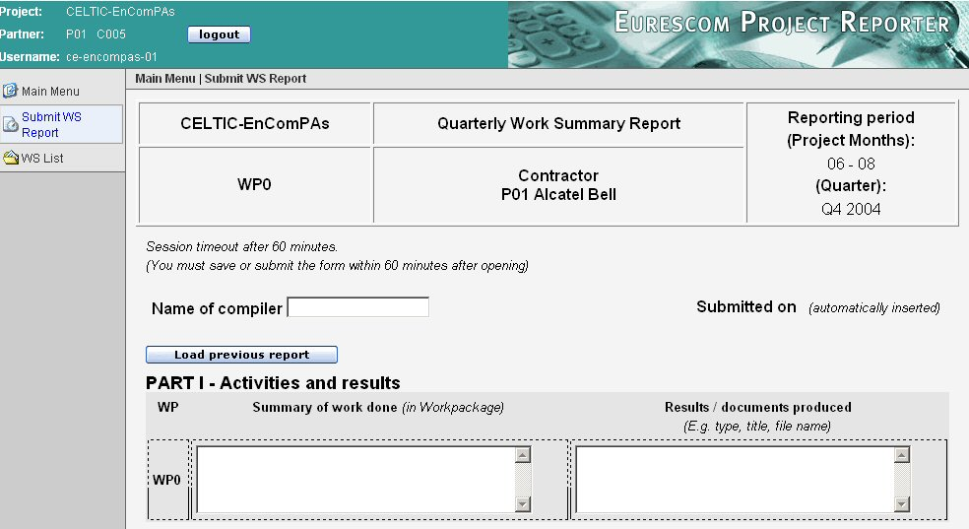
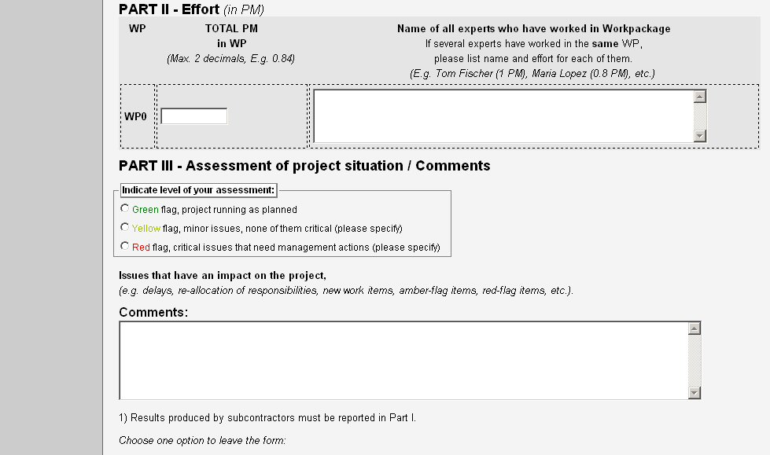
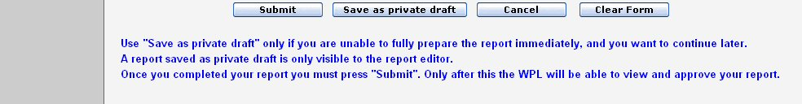
After completing the form it can be submitted by pressing the Submit button. In case the form cannot be completed in the session it can be saved as private draft and opened later for continuation and completion.
Annex 2: Mid-term Review Forms
Mid-term assessment forms
Project Self-Assessment: to be prepared by the PCO at least 14 days before the mid-term review
Project Mid-term Review
Self-Assessment
Acronym:
Project title:
Planned start date | Real start date
Planned finish date | Expected finish date
Involved partners (current status)

Project status and current achievements

Produced deliverables so far:

Types of deliverables (software, prototypes, documents, demos, etc)

Perceived quality of produced results

Perceived quality of current consortium

Dissemination activities so far:

Missed milestones (not produced deliverables, etc

Self-assessment of overall situation and impression of project quality and efficiency:

Encountered or expected problems in the project

Proposals for further improvements

Mid-term Review form: to be prepared by the reviewer(s)
Project Mid-term-Review Report
Acronym:
Project title:
Start: | Duration Months | Budget k€ | Effort PYs
This mid-term review was carried out by (name, company):  - , Main Reviewer  - ,Off-Line Reviewer  - , Celtic Programme Coordinator |  |  | on (date):

- Attendance (Participants from the project and if applicable the representative from the Public Authorities)
- Main scope of the project (Short description of the main scope of the project)
- Review Summary
(Express the impression the overall judgement of the reviewers. What are good/ bad points? Is the project still worth the money?)
In this part the main criteria are:
- Overall impression gained about the project
- Business relevance
- High level view on the technology
- Quality of the documents and the presentations
- Consortium
- Other important aspects
- Recommendations to the project
(What should be improved to overcome detected problems?)
- The conclusion of the MTR was based on the following input documents and results
(Self-assessment, Project descriptions, Deliverables, Milestones, Project reports, MTR presentation during the MTR and Demonstrations)
- Conformity of the work done compared to plans
(How much does the project adhere to the project plans; are there any important deviations from plan? Were the promised results obtained? Are there differences? What consequences can be derived? Were the necessary actions taken?)
- Quality of the results provided so far
(Appreciation of the results based on the evaluation of the project documents and the results shown during the MTR meeting)
- Expected impact of the results
(Available and planned results; degree of innovation, technological advances, market, competitive advantages, impact on business and jobs)
- Quality and efficiency of the project consortium
(What is the overall impression on the quality (expertise, engagement, type of knowledge) of the project consortium? Are the produced results in acceptable relation to the effort and budget used?)
- Missing achievements
(What results should have been expected but are missing. What is the impact of those missing achievements?)
- Unacceptable points
(What is acceptable from the reviewer’s point of view and what must been changed urgently?)

“Impact Assessment of EUREKA Network Projects and Cluster Projects – Main findings and recommendations”. Berlin/Brussels/Graz, May 24, 2017.
“Industry” in the sense of Celtic-Next excludes telecommunication operators.

