Proposal Guidelines
–
celtic Project Proposal (CPP)

The aim of these guidelines is to pragmatically help proposers to prepare a Celtic Project Proposal (CPP).

Proposal Hotline:
The following colleagues at the CELTIC Office are happy to help proposers with any questions regarding
preparation of a CELTIC-NEXT Project Proposal:
- Christiane Reinsch: reinsch@celticnext.eu ; +49 6221 989 210
- Xavier Priem: priem@celticnext.eu ; +49 1515 796 2180

The CELTIC Office offers the possibility that a proposal abstract may be sent in during the proposal phase to get some informal feedback whether the idea is interesting to CELTIC-NEXT and should be progressed. This can avoid unnecessary work if a proposal idea is questionable.
For Proposers who are submitting a CELTIC-NEXT Proposal for the first time, a phone call with the CELTIC Office is recommended.

Timeline to the Celtic Label:
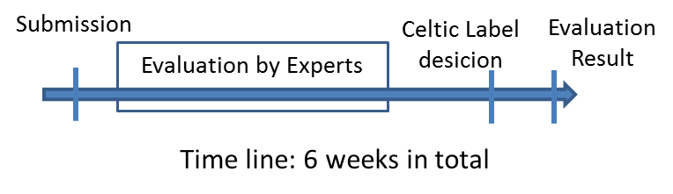

Proposal Submission:
Preparing and submitting a CELTIC-NEXT project proposal is easy.
- Register on the Proposal Submission Tool
- Fill in the forms in the proposal tool
- Upload your proposal in pdf. A template for the proposal can be downloaded from our Guides, contracts and Forms page.

In order to speed up the process it is very important that the consortium partners establish contacts with the national funding authorities already during the proposal preparation phase to check if:
- the proposal covers an interesting and fundable topic for the national research
- the national consortium would be eligible for funding (depending on national funding rules)
- If you wish, you may submit a short proposal abstract (including a short project outline, intended consortium partners/ countries) until one month before the deadline for a first check to the office@celticnext.eu
- NEW: for projects with participation from SWEDEN: To speed up the process the Swedish funding agency VINNOVA proposes an early feedback channel to speed up funding decision after labelling.

When this is confirmed by your national authority, a national funding application should be submitted to the national funding authorities as early as possible. Some countries require a national funding application at the same time as the Celtic-NEXT application – please check with your national authorities.

Possible Research Items:
Basically, all communication related ICT areas are open for proposals.
In detail the CELTIC-NEXT research items are laid down in the CELTIC-NEXT - Scope and Research Areas. This document, as well as the deadlines for submission and evaluation of the proposals, can be found on the CELTIC-NEXT website.
Topics currently high on the ICT agenda are for example Internet of Things, Artificial Intelligence and Big Data, Privacy and Security, 6G and beyond 5G and verticals (such as Smart Transportation, Smart Industry, Smart Health and Smart Cities).

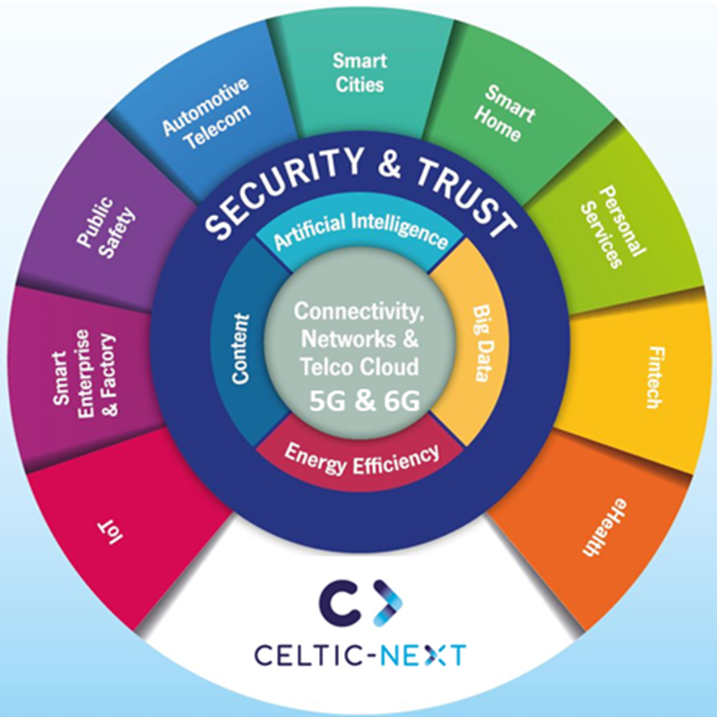

Figure 1: CELTIC-NEXT Research Topics

Some practical hints for the project description:
- Upload your proposal in pdf to the Proposal Submission Tool
- The proposal text should not exceed a total of 50 pages (excluding appendices if any).
- Define a short name (acronym) for the project. In addition to the acronym indicate also the full title. Enter the name and requested contact information of the coordinator (submitter).
- Effort and budget table: Compile the effort and budget figures from the tables further down in order to achieve an immediate overview on effort and requested budget. The requested budget includes both expected contributions from national and from own contributions.
- Please mark, which CELTIC-NEXT technical domains are addressed by the project (cf. CELTIC-NEXT - Scope and Research Areas). Indicate the priority of the addressed domains by assigning one of the following priority numbers:
  - 2 = Main research item (indicated maximum 4 research items that you consider as main focus of the proposal);
  - 1 = Additional research item (areas with a medium important focus, e.g. 20 to 30% of the work);
  - 0 or no mark = Research item not considered.

- Provide concise information for executives on the project scope and expected results. Explain why the project is considered important. Limit the abstract to maximum 2000 characters/25 lines.
- List at a glance all involved partners and the countries where they are located. Indicate also the type of organisation. In case of SME refer to the Eureka definition (< 250 employees).
- Indicate in your CELTIC-NEXT project proposal what the status of the discussions with the National Authorities of the participating countries is. In case of a parallel national funding application please indicate the progress.
- Call the CELTIC Office if anything is unclear (contacts see Proposal Hotline on the first page of this document).

Annex 1: Some practical hints for the individual proposal sections

Abstract and Main Focus
Please provide a crystal clear abstract which can easily be understood also by non-experts.
Main focus: explain the main intention and the goals of the project; if possible attach figures to make your idea better understood.
State-of-the-art situation: describe the current technological situation, the current problems and gaps and indicate current activities on technological improvements. What is the technological state before the project starts. In case there are national differences in the state-of art (SoA) this should be mentioned.
Rationale for the project: explain why you consider this project as important to be carried out; which problems it will solve and why it is necessary that this project should be considered as international project.
Technological innovation and strategic relevance: this chapter is very important as you should explain which technological innovation your project will have achieved at the end of the project. What will be the strategic relevance of your proposal? Describe the expected impact of the project outcome. Describe relationships with related European or national projects. As in the previous chapter this information should also be specified on a per country basis.
Business perspective or business plans: very important for the national funding agencies is also the information about business perspectives at international, but even more, at national level. In some countries a national business plan is required which may be inserted here (at least in main parts). Please check with the national authorities if such a business plan is already needed for the proposal phase or only for the national funding application.
Relevance to Celtic-NEXT: explain the technical and strategic relevance and adherence to the domains in the CELTIC-NEXT - Scope and Research Areas, in terms of technical content, domains addressed, relevance, and links to other important activities (e.g. Future Internet, Green-ICT, CleanTech or energy/ environmental aspects, Smart Cities, Security etc.).
Major visible results: describe the major projected results. Major results may be e.g. new or improved products, new knowledge, patents, developed platforms, implementations, test environments, specifications, standards, SW/HW prototypes.
Contribution to Standards: describe how the project will contribute to standards. Identify standards bodies/ for a where contributions will be made or which shall be influenced.
Dissemination activities and exploitation of results: describe and specify the planned (major) activities to disseminate the results, e.g. publications, brochures, websites, workshops, conferences, etc. Indicate how the results will be further exploited by the partners (e.g. product/ service development, etc.).

Project and Work Organisation
In this chapter you should provide a detailed description how the project will be structured and the work organised. In particular it is important to explain the relationship and work flow between work-packages. Indicate also critical paths and provide an assessment on possible risks. For critical risks provide a contingency plan.
Project structure: describe how the project will be organised (e.g. work package structure, links and relationship between work packages). Provide a technical description for each work package (intended results, milestones, work organisation).
Project Calendar: provide a timeline (Gantt chart or bar diagram that indicates the duration of each WP (and tasks); their interdependencies and milestones (e.g. delivery dates or other important events).
Risk assessment: a risk planning is considered important for a good project plan as it describes actions in the case of possible risk may occur and how the project may react then. Provide a risk analysis and a contingency plan for identified risks. Example:
Type of risk | Risk level | Analysis/contingency
Key software/ hardware products that are needed for a demonstrator are not ready in time | medium | As fallback solution in such case the alternative product <…> will be used
Work breakdown: describe for each work package (WP) the technical work that will be carried out, the expected results, the critical dependencies and the intended use or exploitation of the results. Indicate further work breakdown of each WP (e.g. tasks). Explain also the roles of the partners involved in the work package and their major contributions for that work page. The recommended length of this chapter depends on the number of defined WPs. It should be 1 to 2 pages per WP plus 2 to 3 pages for structure, risk assessment, and calendar.

Project Management
Describe the overall project management structure and management bodies/ committees. Indicate and explain the individual responsibilities in the project (project leader, WP-leaders), the decision-making process, and resolution of conflicts. The recommended length of this chapter is 2 to 3 pages.

Details on Budgets and Funding
Rationale and assumptions for funding: explain why public funding should be granted.
Details on additional budget (equipment, other costs): the budget tables do not provide a specification of costs for equipment, travels or other expenses. As these costs have to be included in the total budget figures you may specify the details on additional costs in a special table that could be inserted in this chapter, e.g. by specifying costs for equipment/ travels, etc. per partner and per year. Also the reasons why the equipment is needed should be given in this section.

Overview of the Consortium
Describe why the consortium has been composed as proposed. Indicate what kind of expertise and role of each partner and how well the available expertise matches with the project requirements. Identify possible gaps in expertise and explain how these gaps will be filled (e.g. by future extensions, or by a complementary national or European project).
Provide a short description of each partner (company profile) and expert involved (CV). Specify responsibilities allocated to experts. Provide for each partner details (in any case e-mail addresses of the identified contact persons must be given).
Provide details on the feedback you received from the related public authorities. It is advised that only one representative of the national consortium partners establishes contacts with the national public authority.
Important note: The composition of the consortium and the selection of the involved countries are of high importance for the acceptance of a proposal by the Public Authorities (PA). It should be carefully investigated with the PAs if funding would be possible for the considered companies or if some re-structuring of the consortium would be necessary. Please check also the Celtic-Next Web site for information about funding conditions.

Effort and Budget Tables
Fill in the tables as indicated. Please note that all figures should be given in person years (PY). The total requested budget (own contributions and funding) should be specified for each year and per country. The figures should be in kEuro.

Appendices (if any)
This section can be used to attach important and related documents to the proposal which are considered relevant for the assessment or labelling. The number of appendices (if any) should be limited to the most important ones.
Annex 2: Project Proposal Review Criteria

The technical review of the proposals is done by the Celtic Group of Experts. These experts evaluate the proposal on the following main criteria:
- Excellence and technological innovation
Excellence of the proposed approach. Extent of innovation potential (beyond the state of the art, e.g. ambitious objectives, novel concepts).
- Strategic relevance and impact
Importance of the project for the European/international society, environment, business, and/or markets (e.g. enhancing innovation capacity, strengthening competitiveness). Potential to provide answers to relevant challenges. Reach of the results within Europe and beyond.
- Potentials for exploitation of the results and for future business
Potential of the project results to be exploited commercially and to lead to future business. Proposed measures to exploit and disseminate the project results (including communicating the project).
- Quality and efficiency of the implementation of the project proposal
Soundness of the concept. Cost of the project vs. planned and required effort. Management approach, including risk management and management of IPRs. Coherence and effectiveness of the work plan, including allocation of work packages, tasks and resources.
- Quality of the proposed consortium
Do the consortium partners cover all required expertise? Excellence of the consortium partners. Complementarity of the participants within the consortium.

Each of the above items can be rated:
5 - excellent
4 - good
3 - fair
2 - poor
1 – inacceptable

Finally each reviewer and the common group of reviewers may give the following recommendation to the Celtic Core group and the Public Authorities:
► Recommended for Celtic-NEXT label
The proposal, from the technical and project planning point of view, has the potential for a successful project. There are always feedback comments. In some cases it can be mandatory to react to these comments (this is explained in the individual Labelling Letters).
► Not recommended for Celtic-NEXT label
The presented project proposal is not convincing or not suitable for a Celtic-NEXT project. It may be resubmitted to one of the next calls after a major rework or it may not be recommended for any further re-submission to the next Celtic-NEXT call.

