CELTIC-NEXT Autumn Call: Next Generation Communications for the Digital Society
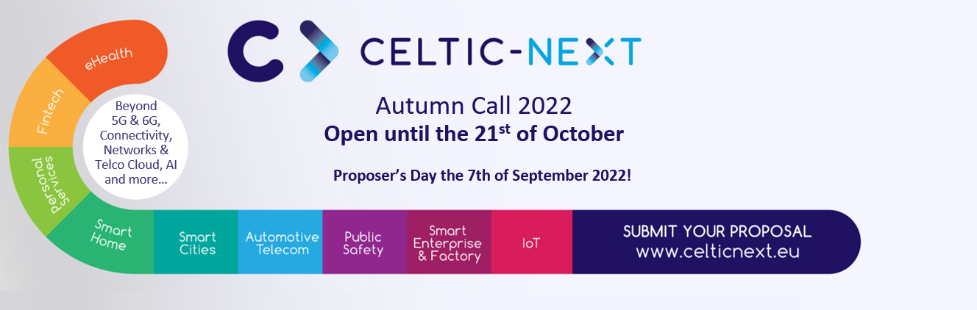

Period: 7th of July 2022 to 21st of October 2022
The Eureka Cluster CELTIC-NEXT launches two Calls per year one in Spring and one in Autumn.
CELTIC is pleased to announce its 2022 Autumn Call, a perfect opportunity to enable projects in the field of next-generation communications for the digital society that contribute to a sustainable world. We invite you to participate, engage and explore ground-breaking opportunities together with the CELTIC-NEXT Cluster.
By applying and participating in the CELTIC-NEXT Call, your organization can access national public funding for your R&D project.
You can submit your R&D&I project application from the 7th of July 2022 to the 21st of October 2022 by visiting https://www.celticnext.eu/autumn-call-2022/ .

PARTICIPATING COUNTRIES
https://www.celticnext.eu/national-public-contacts-funding-schemes/
Please note that Sweden, as of today, cannot support the Autumn Call 2022. If you wish to make a proposal for this call with part of the consortium in Sweden, please consider joining as self-funded partners. If you cannot or do not wish so, please consider the Spring Call 2023 as the next opportunity to apply with the Swedish consortium. Please contact the CELTIC-NEXT Office office@celticnext.eu for more details and potential strategies to apply.

SCOPE
CELTIC-NEXT includes a wide scope of ICT topics based on new high-performance communications networks supporting data-rich applications and advanced services, both in the ICT sector and across vertical sectors. We invite you to engage and explore ground-breaking opportunities that contribute to a sustainable world. CELTIC is key for initiating ambitious and innovative projects dedicated to end-to-end communications solutions
Until today, CELTIC has labelled, funded and performed 163 projects in all their research areas with a total volume of more than 1.2 billion Euro. By facilitating these collaborative R&D projects, the CELTIC cluster has made a great contribution to help Europe to stay at the competitive edge of the information and communications technologies industry.
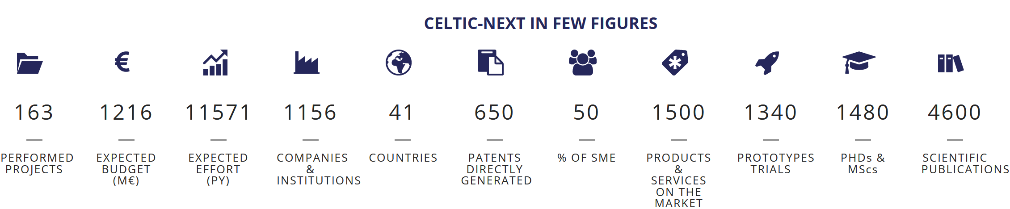
The industry driven Cluster CELTIC and its vision has been laid in the CELTIC Scope and Research Areas document to downloaded from the bottom of the CELTIC-NEXT Research Areas page.
Please do not hesitate to study this document.
In addition to the entire scope of the CELTIC Strategic Roadmap, CELTIC is also looking for projects in the field of Non-Terrestrial-Networks and Terrestrial Networks convergence, as we are developing our partnership with the European Space Agency, along the topics to be read in the corresponding article in the CELTIC News from first half 2022. Projects will be able to join the future collaborative actions.
Some funding public authorities have also expressed their additional interest into:
Digitalisation of the Economy thanks to ICT technologies, Clean Growth, Remote Health & Care, advanced manufacturing, critical coms for emergencies, Open RAN, Private Networks, AI for Massive MIMO, IOT, I-IOT, 6G topics. Please contact CELTIC-NEXT Office office@celticnext.eu for more details and potential strategies to apply.

ELIGIBILITY
Participation is open to companies of all sizes, universities and research organisations.
By participating in the CELTIC Call for projects, you benefit from:
- receiving a Cluster Label,
- access to national R&D funding,
- an international network of companies including key industry players,
- guidance, coaching and monitoring of your project by the CELTIC Office,
- low administrative requirements
CELTIC-NEXT is the Eureka Cluster for next-generation communications for the digital society.
Please get in early contact with:
- Your public authorities: https://www.celticnext.eu/national-public-contacts-funding-schemes/
- The CELTIC Office please, please send an Email to office@celticnext.eu

Timeframe
- Start submission phase: 7th of July 2022
- Online Proposers Day: 7th of September 2022
- Online Consortium Building Sessions: 8th and 9th of September 2022
- Submission deadline: 21st of October 2022
- Evaluation of proposals finished: 2nd December 2022
- Labelling of proposals: December 2022
- Information to proposers: December 2022

Applying
Making a CELTIC-NEXT project proposal is easy, full project proposals are expected to be submitted covering new innovative ideas covering the scope of the CELTIC cluster.
- Contact your national funding body and the CELTIC Office and discuss your project idea and eligibility aspects.
- Create an account on the Eureka Clusters Project Portal fill in the Web-forms, and upload your Project Proposal in pdf until the submission deadline.
- Visit the Call information page for further information.

Consortium Building
CELTIC-NEXT offers several opportunities for meeting potential project partners:
The CELTIC-NEXT Cluster successfully organizes several Proposers Days per year as well as an yearly CELTIC Event to bring together the pitch presenters with the funding bodies as well as successful CELTIC project coordinators that present regularly their impact on the market to the audience. You can also meet at these occasions CELTIC Award winners and learn about the impact of successful projects impact and about successful SMEs born out of our CELTIC projects. At the CELTIC Event you can also get in touch with CELTIC projects through a lively project exhibition.
- Get in contact with the CELTIC Community! Learn about funding in your country and pitch your project idea at the next CELTIC Proposers Day or the yearly CELTIC Event.
- Get in contact with project proposers and find out if your expertise is needed via
New Project Ideas
- Submit your expertise or new project idea any time via the CELTIC Brokerage tool

Contacts
Please do not hesitate to get in contact with us and follow us on social media. The CELTIC Office is happy to support you!
Email: office@celticnext.eu
Website: www.celticnext.eu
Events: https://www.celticnext.eu/?post_type=tribe_events
Twitter: https://twitter.com/CelticNext
LinkedIn: https://www.linkedin.com/company/celtic-next/

