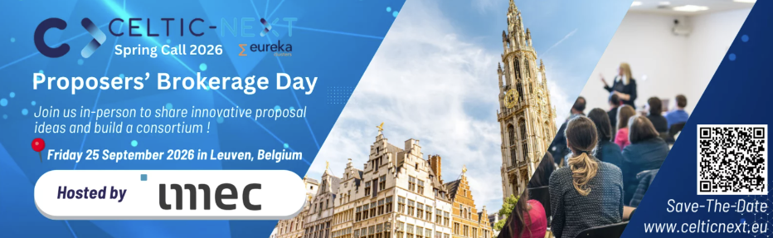
CELTIC-NEXT is pleased to announce its in-person Proposers’ Brokerage Day, taking place on 25 September 2026 at imec in Leuven, Belgium.
The event will bring together researchers, companies, SMEs, innovators and public authorities to exchange ideas, find potential project partners and build strong international consortia for the next generation of communication systems, trusted digital infrastructures and advanced connected services.
The CELTIC-NEXT Autumn Call 2026 is open until 26 October 2026, making the Brokerage Day an ideal opportunity to develop your project idea and connect with potential partners before the proposal deadline.
Participants will have the opportunity to present short pitches, exchange with potential partners, and engage directly with national funding representatives. The Proposers Day is designed to help you refine your proposal, identify collaboration opportunities, and form strong international consortia capable of addressing the challenges of future communication systems.
Take an active part and join the pitching session:
Jump start your project and send us (event@celticnext.eu) your new project idea using the pitch– and poster-template at the latest until 10th of September (please see event page for updates). Keep in mind to limit your talk to 6 minutes. You can send us your pitch and poster already before the deadline to receive early feedback from us. The posters will be printed and brought to Leuven if you send them until 10th of September. Please note this is an in-person session. If you want to see previous project pitches please visit our new-ideas page.
Alongside the pitching sessions and project presentations, public authorities will be present to explain national funding opportunities and support mechanisms available across participating countries. Dedicated networking time will also be provided to encourage discussions and match complementary expertise across organisations.
Whether you already have a mature proposal or are still shaping your idea, this day is intended to support meaningful collaboration and accelerate the transition from concept to consortium.
By participating in this Brokerage Day, organisations can position themselves within a large-scale European innovation ecosystem and access national public funding for R&D projects in advanced digital technologies.
Venue
imec 1, Kapeldreef 75
Leuven, 3001 Belgium

